Name: **Junaid Hashmi**

Assignment 1: Visualization

Data Source: Global_Education

1. **Scatter Plot**

I have created a scatter plot that visualizes the relationship between latitude and longitude, using the 'Latitude' and 'Longitude' columns from my dataset. This also incorporates a third variable, 'Completion_Rate_Primary_Male', to add meaningful context to the plot. My visualization helps to explore how completion rates for primary education among males vary across different geographic locations.

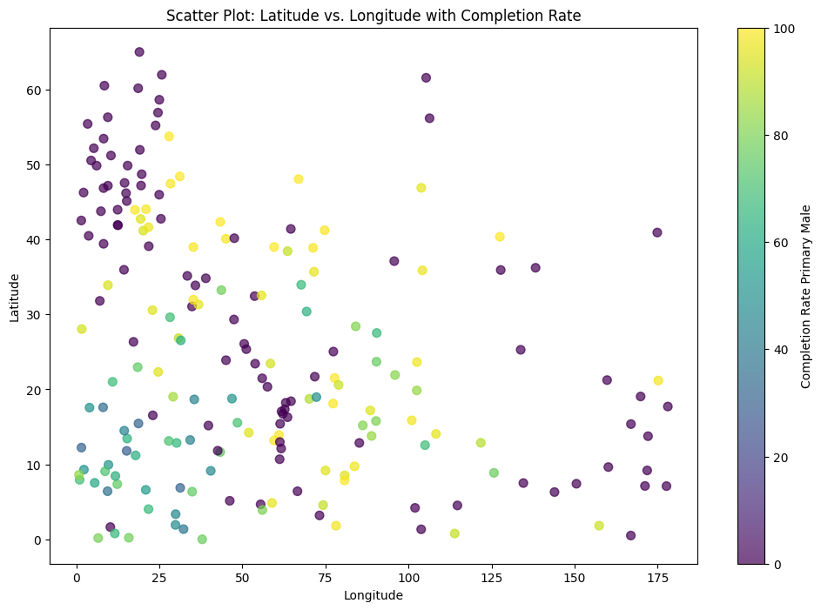

**Data Description:**

My dataset contains information related to education, geographical locations, and demographic factors. Each row in the dataset represents a specific country or area, and the columns provide various data points for those locations. For scatter plot we have chooses Two columns.

**Benefits of Scatter Plot:**

This scatter plot can be used as a good example for a scatter plot that can visualize a relationship between two or more variables.

**Conclusions:**

My scatter plot not only displays the geographic locations (latitude and longitude) but also associates each data point with a color indicating the primary male completion rate. As such, it helps us to explore any geographical patterns or trends in primary education completion rates.

**2. Bar Chart**

I have used bar chart, which is a suitable choice when we want to compare values across categories, in this case, countries or areas. A bar chart represents data with rectangular bars, where the length or height of each bar is proportional to the value it represents.

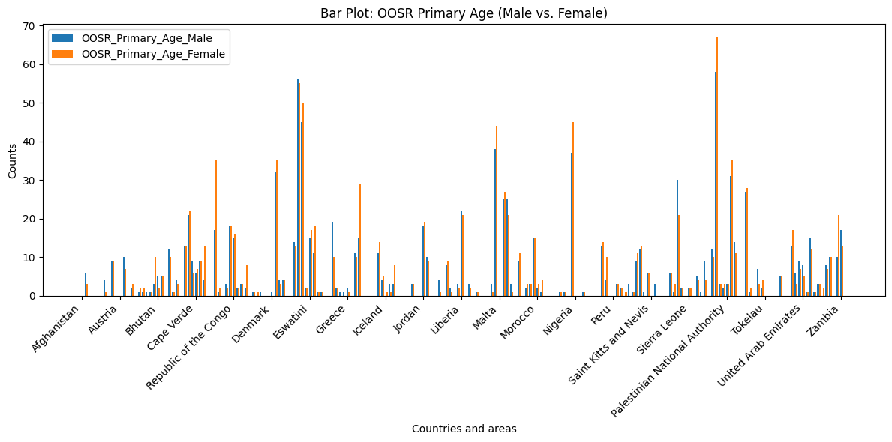

**Data Description:**

My dataset contains information related to education, geographic locations, and demographic factors for various countries and areas. It includes a range of columns representing educational and demographic indicators, and for this specific visualization, I have focused on out-of-school rates for primary-age individuals, separated by gender.

**Benefits of Using Bar Chart:**

Bar charts are excellent for comparing values or categories. In this case, it allows us for a clear comparison of out-of-school rates between primary-age males and females in different countries or areas. The side-by-side bars make it easy to visually assess the disparities or similarities in these rates.

The side-by-side bars for males and females facilitate us to direct visual comparison. Viewers can immediately see how the out-of-school rates differ for each gender in each country, highlighting disparities and trends.

**Conclusion:**

In this particular visualization, the data flows from your dataset into the bar chart. The 'OOSR_Primary_Age_Male' and 'OOSR_Primary_Age_Female' columns from the dataset are used to create the bars for the bar chart. Each bar in the chart represents the out-of-school rate for either primary-age males or females in a specific country or area.

The bar chart is effective for comparing these rates across different locations, enabling you to identify variations in primary education accessibility between genders in various regions. It provides a clear visual representation of the data, making it easier to draw conclusions and insights regarding primary education disparities.

**3. Line Plot**

Line plots are well-suited for representing continuous data over a range of categories or values. my dataset contains completion rates for various education levels (e.g., primary, lower secondary, upper secondary) across different countries or areas. Using a line plot allows us to observe how these completion rates change continuously across the dataset.

I have visualized a line plot, which is suitable for showing how completion rates change over a range of categories (in this case, different education levels) for multiple countries or areas.

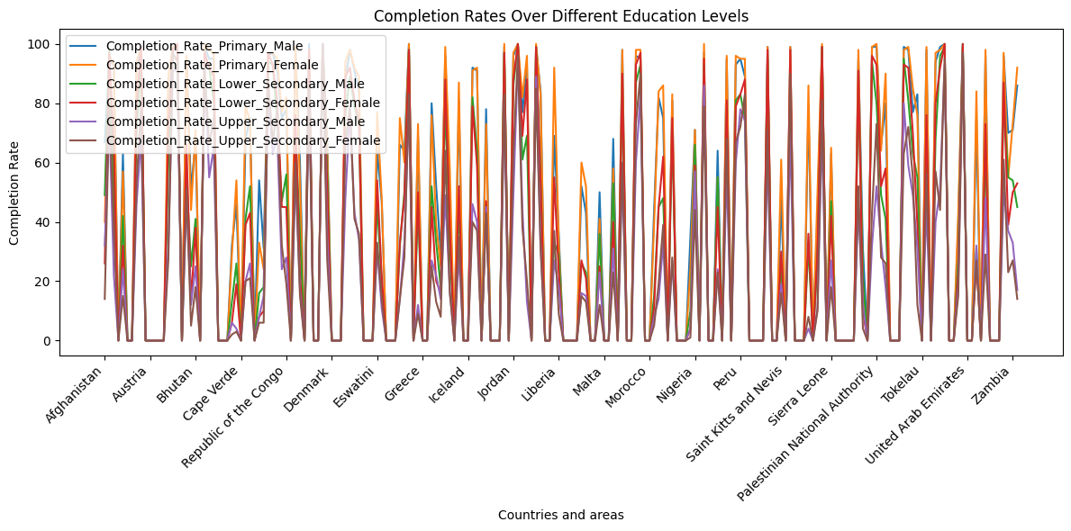

**Data Description:**

My dataset contain information related to education and completion rates across different countries or areas. Each row represents a specific country or area, and the columns contain various indicators and completion rates. The dataset includes information on primary, lower secondary, and upper secondary education completion rates, both for males and females, which provides insights into the educational progress in these regions.

**Benefits of Using Line Plot:**

The line plot visualizes how completion rates vary for different education levels, helping to identify any patterns, disparities, or trends among the countries or areas. It provides a clear overview of how education completion rates are distributed across regions and can be valuable for analysis and comparison.